Agentic AI & AI Agents - Top MNC Interview Questions and Answers

https://youtu.be/FWtEOeBJcgo?si=y2elIpukkz33GU4H
~ Prepared by Riya Kharade

1. Introduction

This documentation is based on an in-depth technical video that explores AI Agents and Agentic AI from both theoretical and practical perspectives. The video provides a comprehensive walkthrough of how modern AI systems are designed to move beyond static, task-specific models into autonomous, goal-driven, and adaptive agents.
The discussion begins by defining what an AI agent is and how it differs from traditional AI systems. It then explains the Sense–Think–Act loop, which forms the foundation of agent behavior. The video further covers different types of agents, including reactive, deliberative, hybrid, and BDI (Belief–Desire–Intention) agents, along with real-world examples to illustrate their use.
In addition, the video deeply examines autonomous agents versus intelligent assistants, the role of environments in shaping agent behavior, and the differences between single-agent and multi-agent systems. Concepts such as coordination, cooperation, communication protocols, emergent behavior, and scalability in multi-agent environments are also discussed in detail.
A significant portion of the video focuses on Agentic AI, highlighting how it extends traditional agents by incorporating long-term memory, self-reflection, goal decomposition, recursive reasoning, and proactive planning. The video also explains the importance of reinforcement learning, tool integration, modern agent frameworks, and memory architectures in building reliable agentic systems.
Finally, the video addresses practical challenges and real-world considerations, including performance evaluation, failure handling, hallucination mitigation, security risks, ethical concerns, human-in-the-loop design, enterprise deployment challenges, and future directions of agent-based AI systems.
Overall, the video serves as a complete guide to modern AI agents and Agentic AI, making it highly relevant for students, researchers, and professionals working on next-generation intelligent systems.
2. What is an AI Agent?
An AI agent is an autonomous system that:
- Perceives its environment
- Decides actions based on goals
- Acts to change the environment
- Learns from feedback
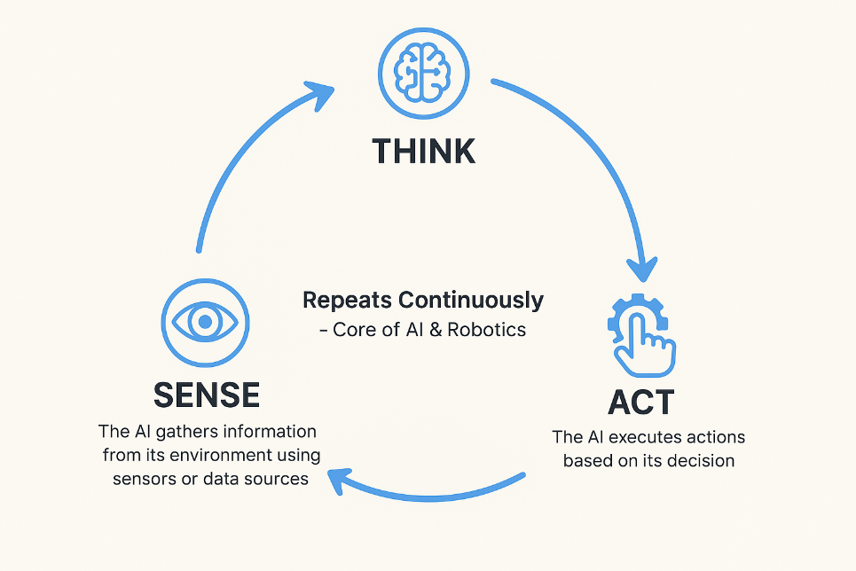
Key Difference from Traditional AI:
Traditional AI | AI Agent
Task-specific | Goal-oriented
Static | Adaptive
Prediction-focused | Decision + Action
No autonomy | Autonomous

Example:
A prediction model forecasts stock prices, while an AI agent decides when to buy/sell and adapts to market changes.

3. Sense–Think–Act Loop
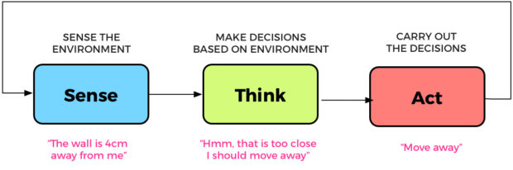
The Sense Think–Act loop is the fundamental operational cycle of an AI agent.
- Sense - Collects information from the environment (APIs, sensors, user input)
- Think - Reasons, plans, and selects the best action
- Act - Executes the chosen action
- Feedback - Observes results and adjusts future behavior
This loop runs continuously, allowing the agent to adapt dynamically.
Example:
A self-driving car senses traffic conditions, thinks about braking or lane changes, and acts by controlling steering and speed.

4. Types of AI Agents
4.1 Reactive Agents
- Respond directly to inputs
- No memory or planning
- Fast but limited
Example: Thermostat controlling temperature.

4.2 Deliberative Agents
- Maintain internal models of the world
- Plan future actions
- Suitable for complex reasoning
Example: Chess-playing AI.
4.3 Hybrid Agents
- Combine reactive and deliberative approaches
- Used in real-world systems
Example: Autonomous robots.

4.4 BDI Agents (Belief–Desire–Intention)
- Beliefs: Knowledge about the world
- Desires: Goals to achieve
- Intentions: Committed plans
These agents mimic human-like reasoning and decision-making.

5. Autonomous Agents vs Intelligent Assistants
Intelligent Assistant | Autonomous Agent
Reactive | Proactive
User-driven | Goal-driven
Executes commands | Takes initiative
Short-lived tasks | Long-term objectives

An intelligent assistant responds to commands, while an autonomous agent continuously works toward goals without constant human input.

  - Role of Environment in Agent-Based Systems
The environment is the context in which an agent operates and directly affects its design.
Environment Characteristics:
- Static vs Dynamic
- Deterministic vs Stochastic
- Fully observable vs Partially observable
Examples:
- Chess: Fully observable, deterministic
- Stock market: Partially observable, uncertain
Agents must be designed according to environmental complexity.

7. Single-Agent and Multi-Agent Systems
1. Single-Agent Systems
- One agent
- Independent goal
- Simpler design
Example: Robotic vacuum cleaner.

2. Multi-Agent Systems
- Multiple agents
- Cooperation or competition
- Require communication and coordination
Example: Warehouse robots, drone swarms.

8. Measuring Performance of AI Agents
Agent performance is evaluated using multiple metrics:
- Task success rate
- Efficiency (time and cost)
- Adaptability
- Robustness to failure
- User satisfaction
There is no single metric; evaluation depends on the application.

9. AI Agents vs Agentic AI
AI Agents | Agentic AI
Task-focused | Process-focused
Reactive | Proactive
Limited memory | Long-term memory
Minimal self-evaluation | Self-reflective

Agentic AI systems plan multi-step strategies, monitor progress, and self-correct over time.

10. Importance of Memory in Agents
Memory enables:
- Context awareness
- Personalization
- Long-term goal tracking
Types of Memory:
- Short-term memory: Session context
- Long-term memory: User preferences and history
Without memory, agents feel robotic; with memory, they feel intelligent and reliable.

11. Reinforcement Learning in Agent Design
Reinforcement Learning (RL) allows agents to learn through:
- Trial and error
- Rewards and penalties
- Continuous interaction with the environment
RL is critical for dynamic and uncertain environments.

12. Tool Use and Modern Agent Architectures
Modern agents treat tools as actions:
- APIs
- Databases
- Search engines
- External services
Tool integration increases agent capability beyond static knowledge.
\
13. Failure Handling and Reliability
Common Failures:
- Incorrect planning
- Tool or API failure
- Environmental changes
Solutions:
- Error handling
- Self-correction loops
- Fallback strategies
- Human-in-the-loop escalation

14. Security, Ethics, and Alignment
Key concerns include:
- Hallucinations
- Unauthorized actions
- Prompt injection
- Over-autonomy
Mitigation strategies:
- Permission boundaries
- Audit logs
- Human approvals
15. Industry Applications of Agentic AI
- Healthcare automation
- Financial analysis and risk management
- Customer service workflows
- Supply chain optimization
- Software development assistance

Conclusion
AI agents represent a major shift from static automation to autonomous, intelligent systems. Agentic AI extends this capability by enabling long-term planning, self-reflection, memory, and collaboration. While challenges remain in reliability, security, and alignment, agent-based architectures are set to play a critical role in the future of intelligent systems across industries.

